Step 1: sudo -i

Step 2: passwd

(set password for root)

Step 3: yum update

Step 4: yum install wget

Step 5: wget http://repo.mysql.com/mysql-community-release-el7-5.noarch.rpm

Step 6: rpm -ivh mysql-community-release-el7-5.noarch.rpm

Step 7: yum update

Step 8: yum install mysql-server

Step 9: service mysqld status

Step 10: systemctl start mysqld

Step 11: service mysqld status

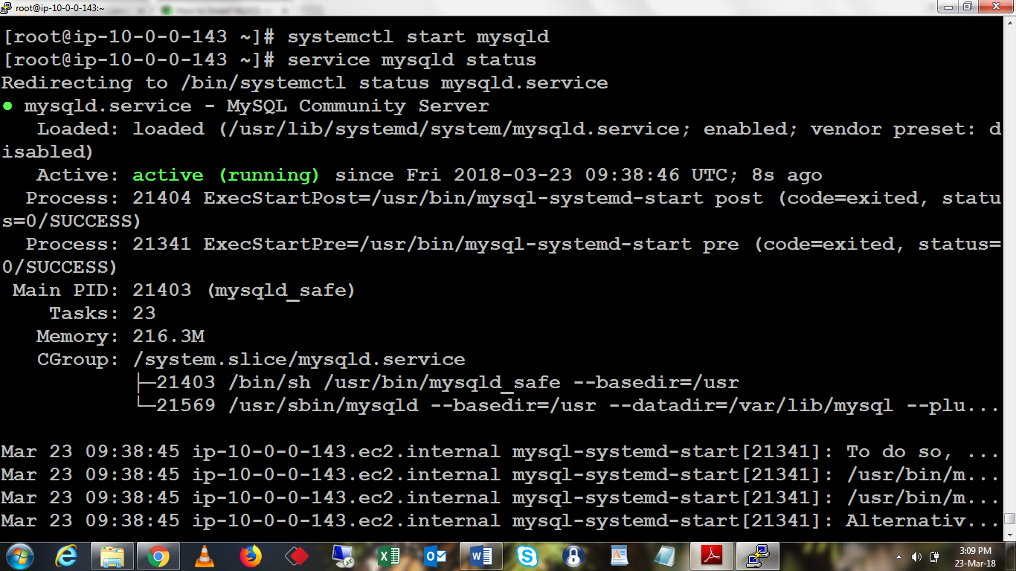

Step 12: mysql_secure_installation

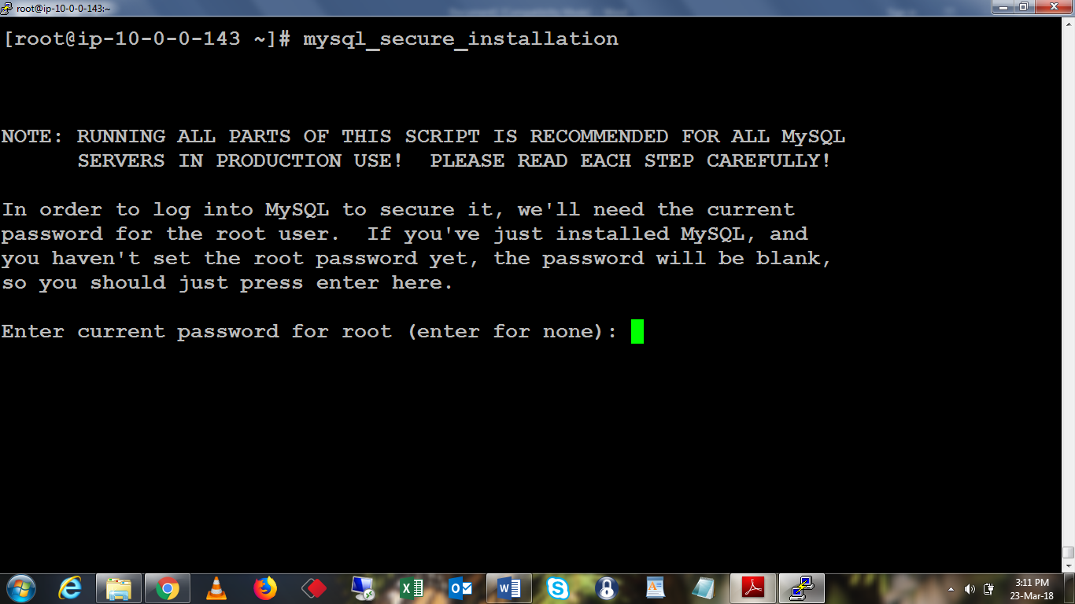

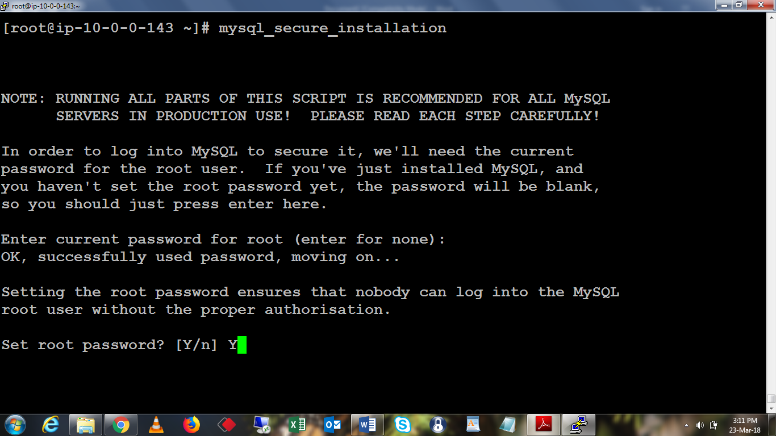

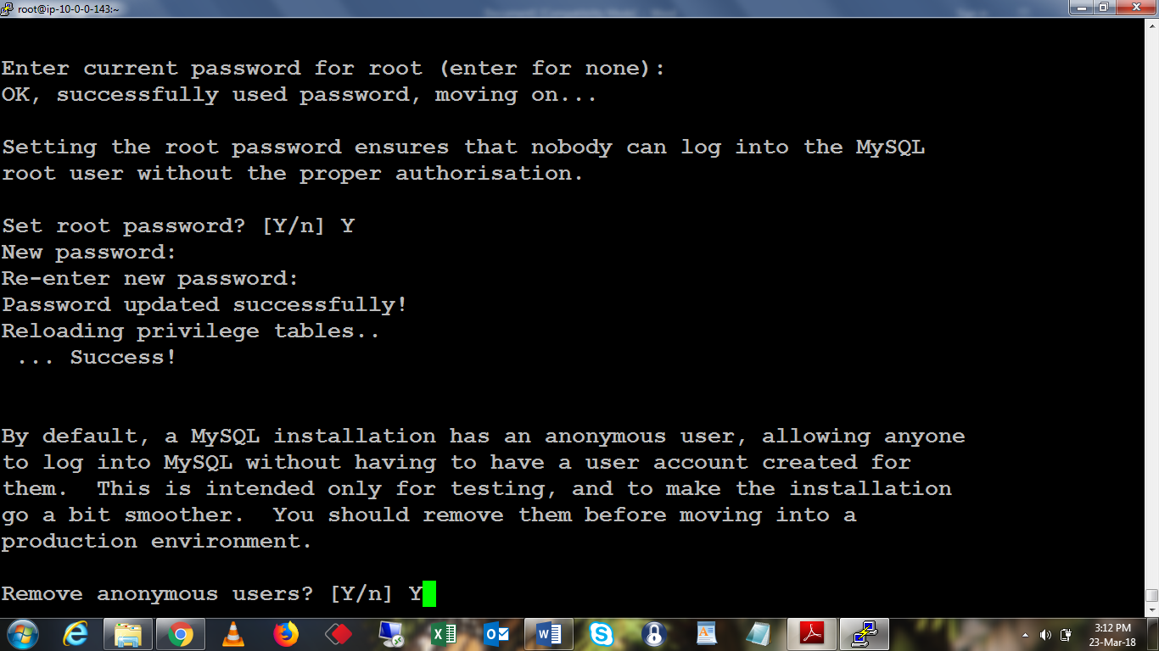

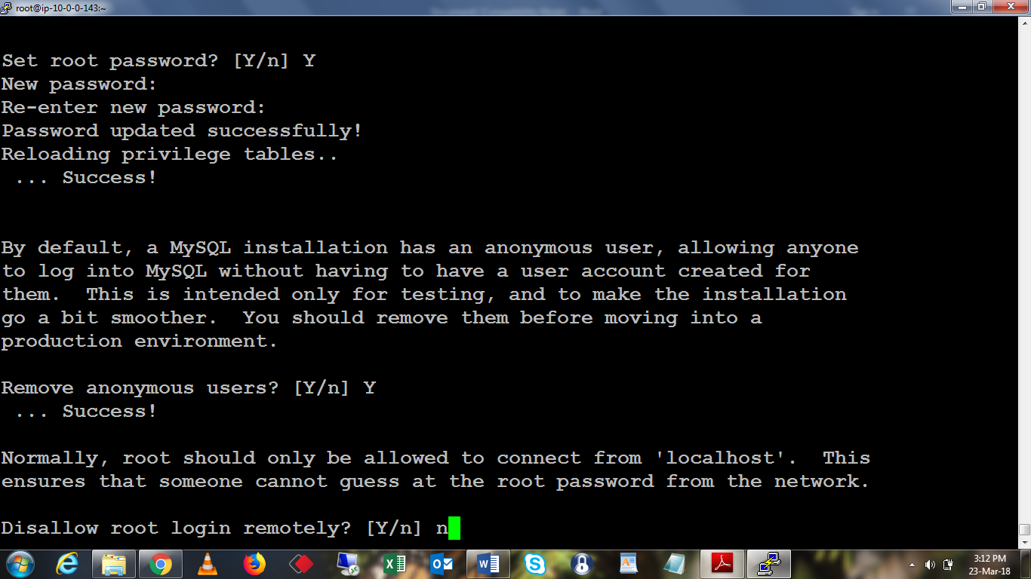

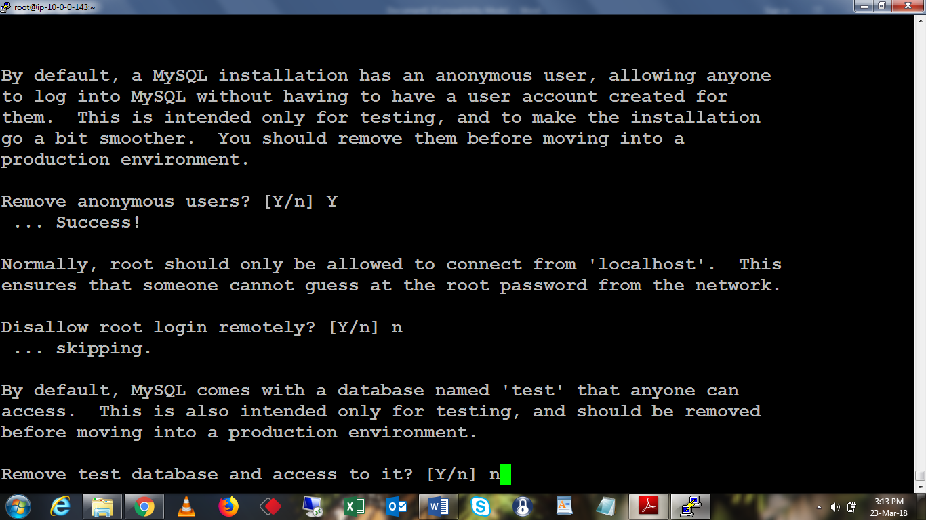

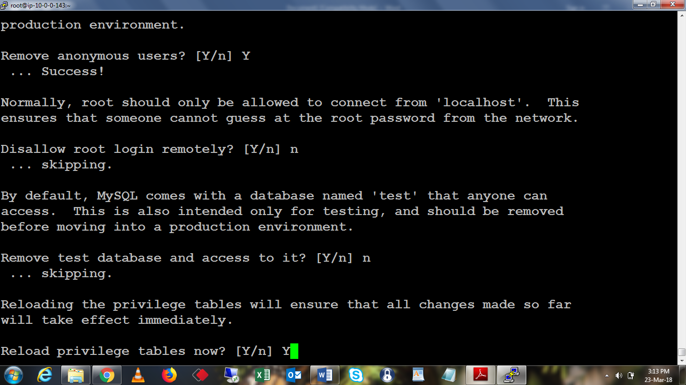

Step 14: mysql -u root -p

create database metastore DEFAULT CHARACTER SET utf8;

grant all on metastore.* TO 'hive'@'%' IDENTIFIED BY 'P@ssw0rd';

create database hue DEFAULT CHARACTER SET utf8;

grant all on hue.* TO 'hue'@'%' IDENTIFIED BY 'P@ssw0rd';

create database rman DEFAULT CHARACTER SET utf8;

grant all on rman.* TO 'rman'@'%' IDENTIFIED BY 'P@ssw0rd';

create database navs DEFAULT CHARACTER SET utf8;

grant all on navs.* TO 'navs'@'%' IDENTIFIED BY 'P@ssw0rd';

create database navms DEFAULT CHARACTER SET utf8;

grant all on navms.* TO 'navms'@'%' IDENTIFIED BY 'P@ssw0rd';

create database oozie DEFAULT CHARACTER SET utf8;

grant all on oozie.* TO 'oozie'@'%' IDENTIFIED BY 'P@ssw0rd';

create database actmo DEFAULT CHARACTER SET utf8;

grant all on actmo.* TO 'actmo'@'%' IDENTIFIED BY 'P@ssw0rd';

create database sentry DEFAULT CHARACTER SET utf8;

grant all on sentry.* TO 'sentry'@'%' IDENTIFIED BY 'P@ssw0rd';

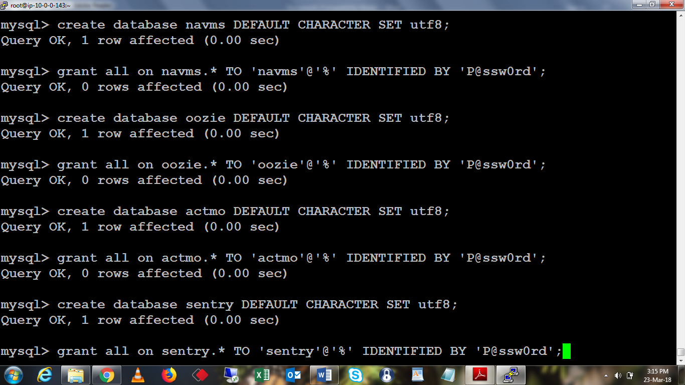

grant all on *.* to 'temp'@'%' identified by 'P@ssw0rd' with grant option;

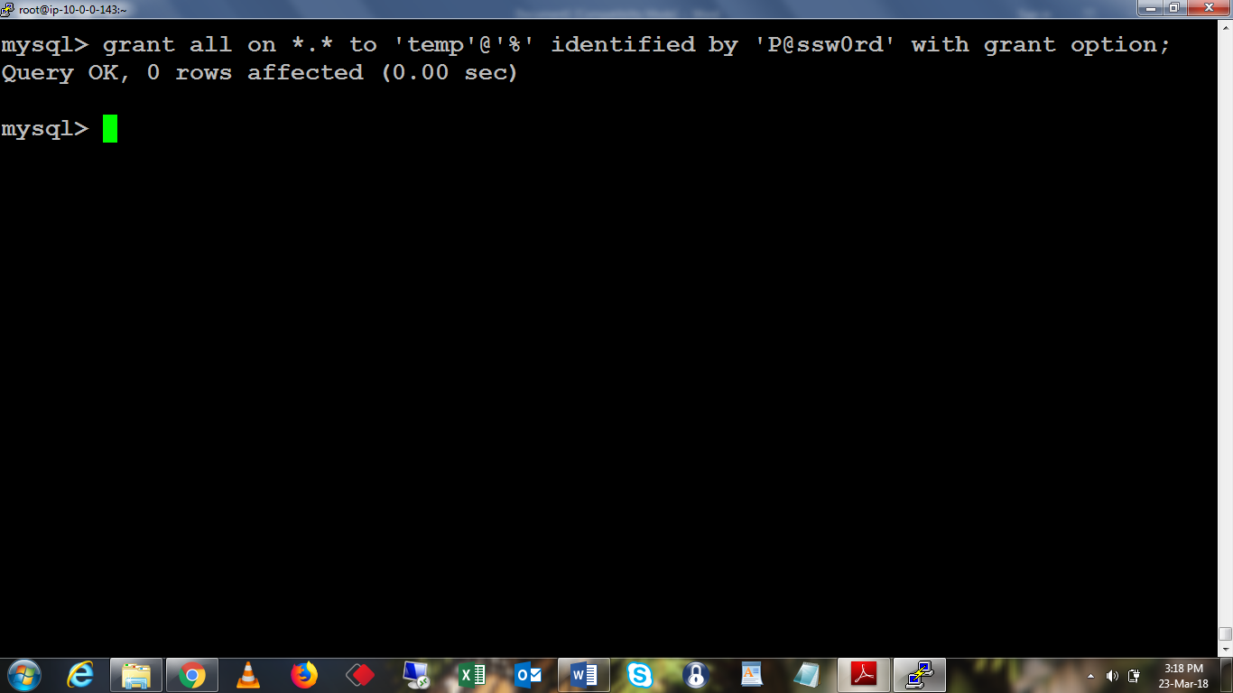

Exit

chkconfig mysqld on

yum install mysql-connector-java

cd /etc/ yum.repos.d/

wget <https://archive.cloudera.com/cm5/redhat/6/x86_64/cm/cloudera-manager.repo>

vi cloudera-manager.repo

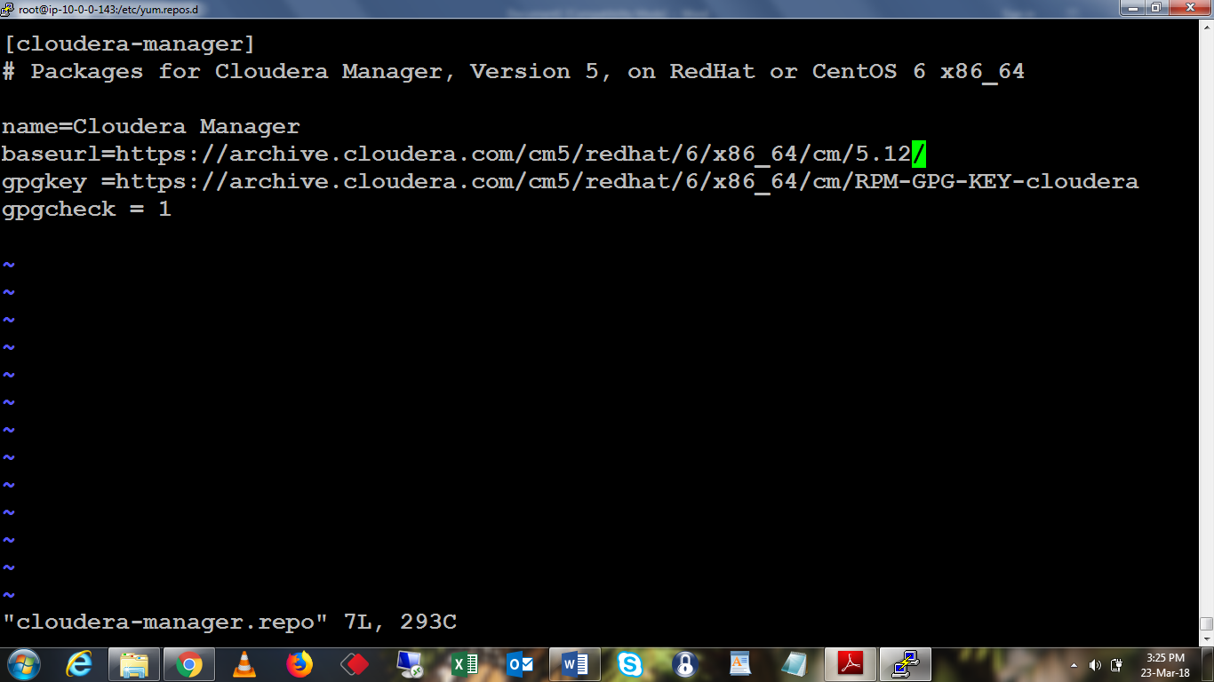

Cd

yum install oracle-j2sdk1.7

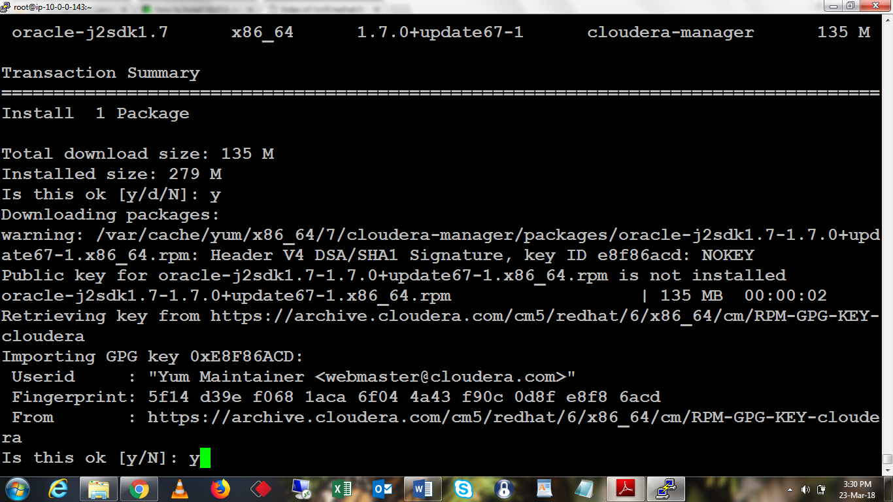

ls -la /usr/java

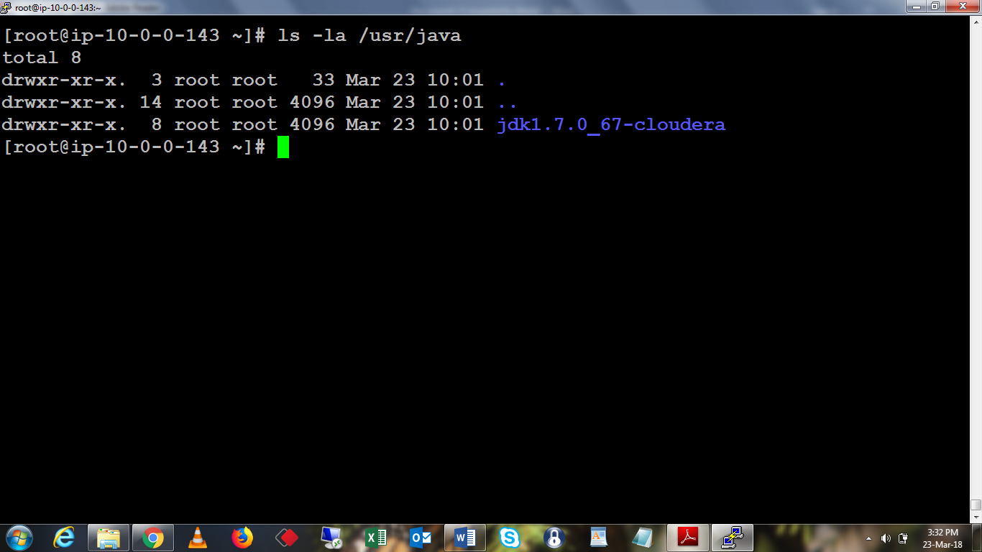

yum install cloudera-manager-server cloudera-manager-daemons

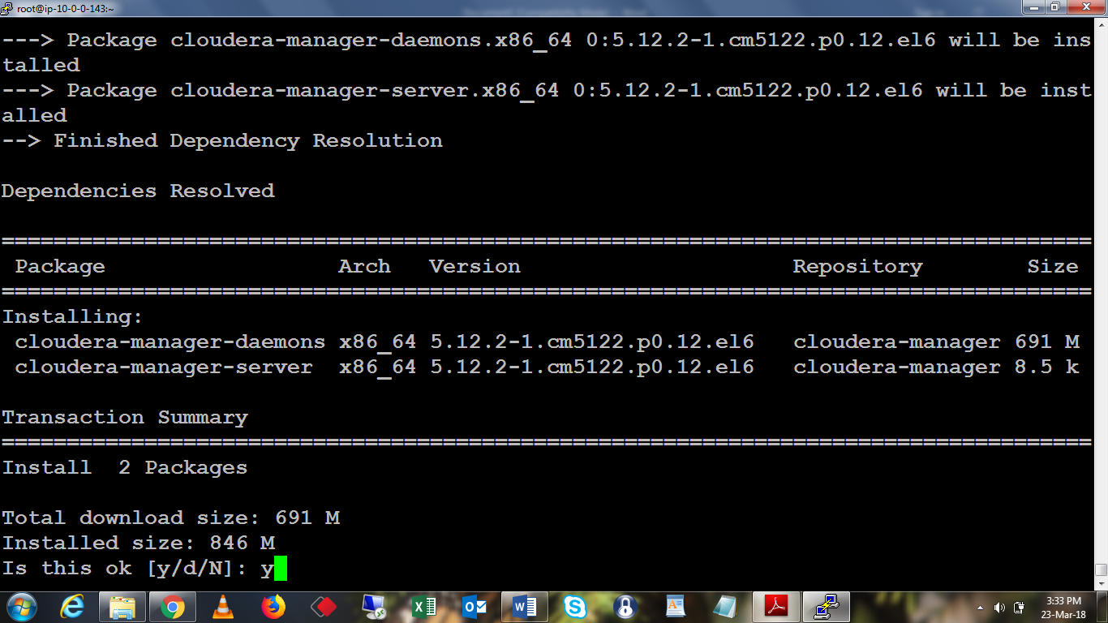

rpm -qa 'cloudera-manager-*'

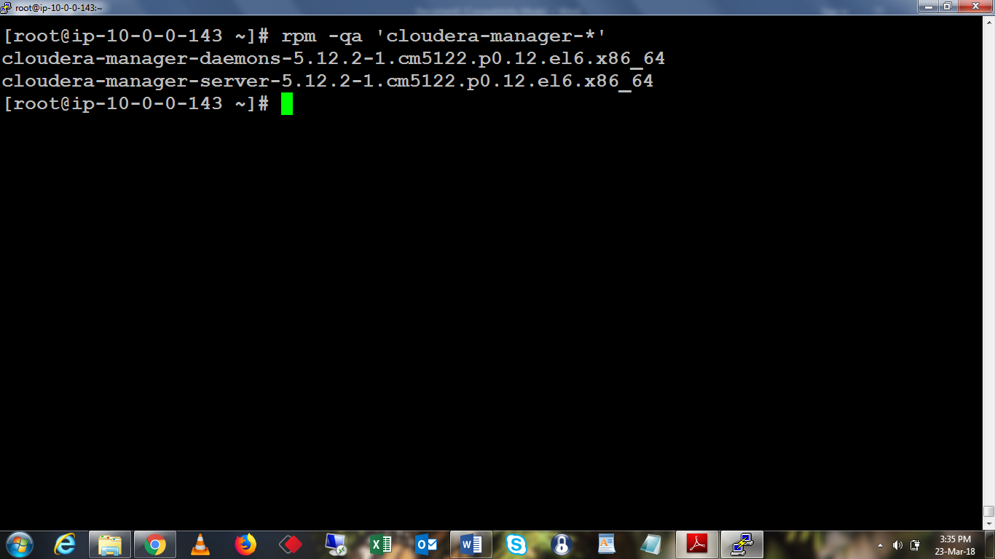

mysql -u root -p

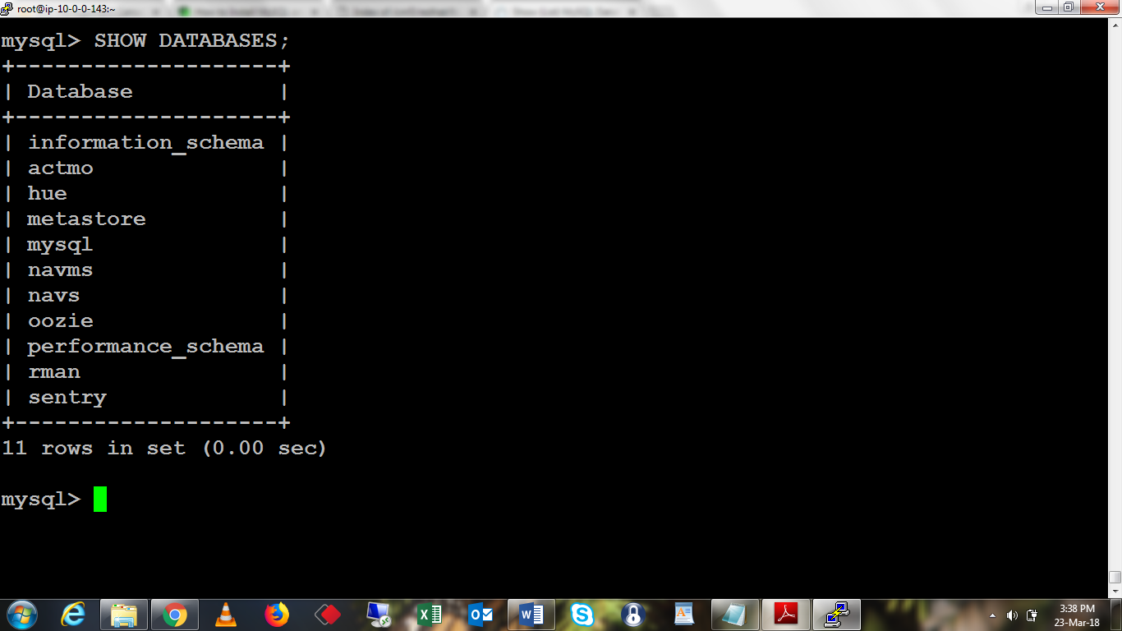

Exit

/usr/share/cmf/schema/scm_prepare_database.sh mysql -h ip-10-0-0-143.ec2.internal -utemp -pP@ssw0rd --scm-host ip-10-0-0-143.ec2.internal scmdb scmusr P@ssw0rd

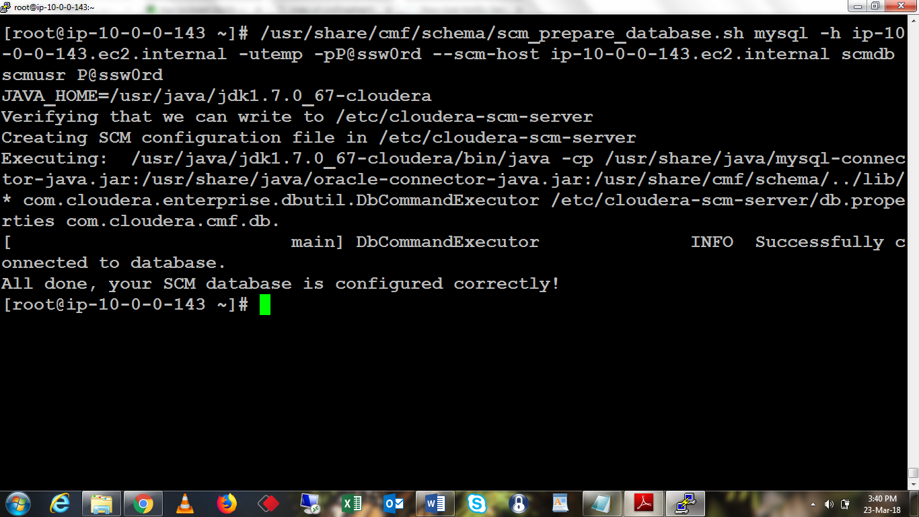

mysql -u root -p

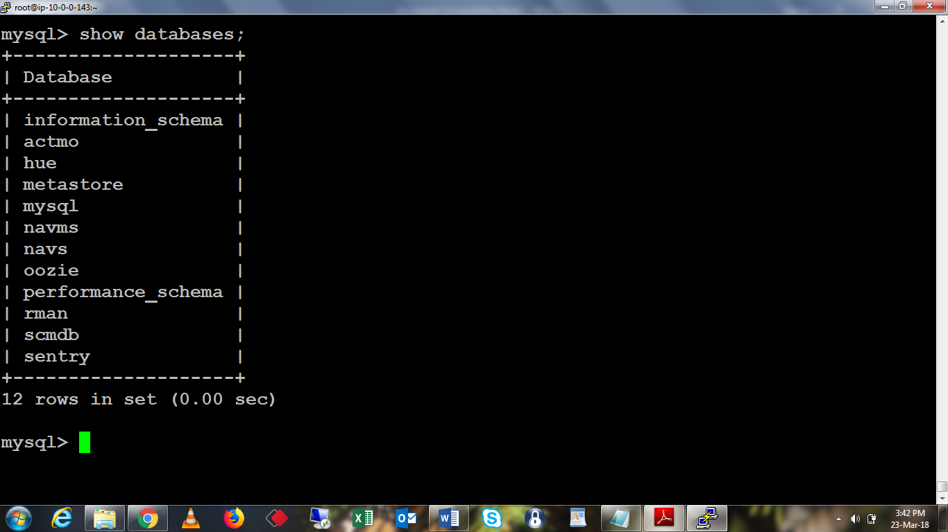

less /etc/cloudera-scm-server/db.properties

(for exit Press :q Enter)

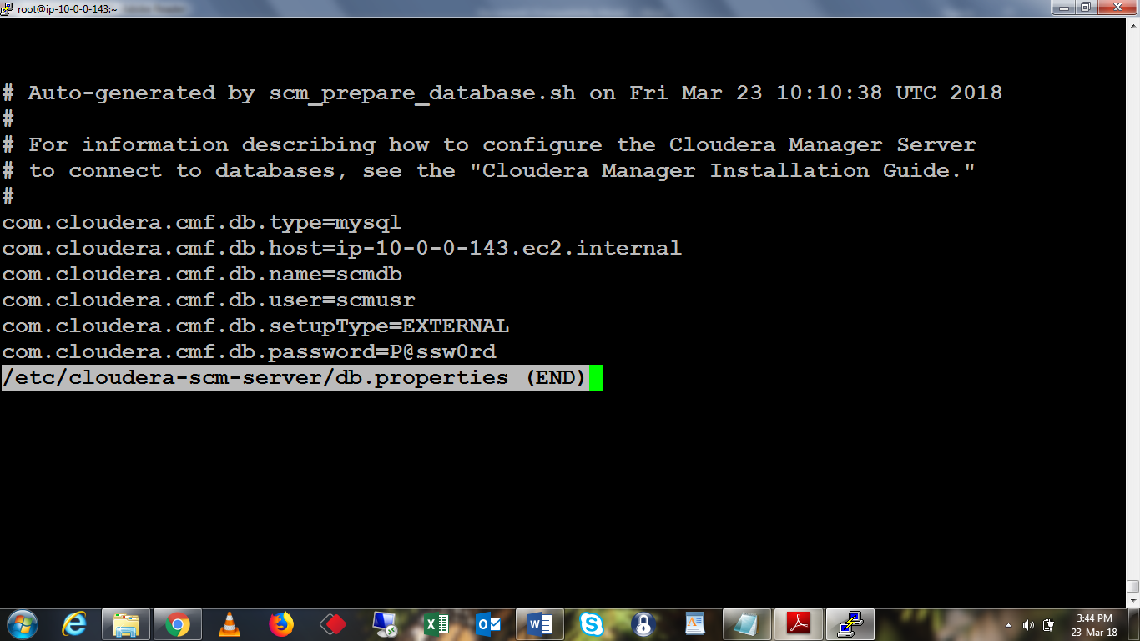

drop user 'temp'@'%';

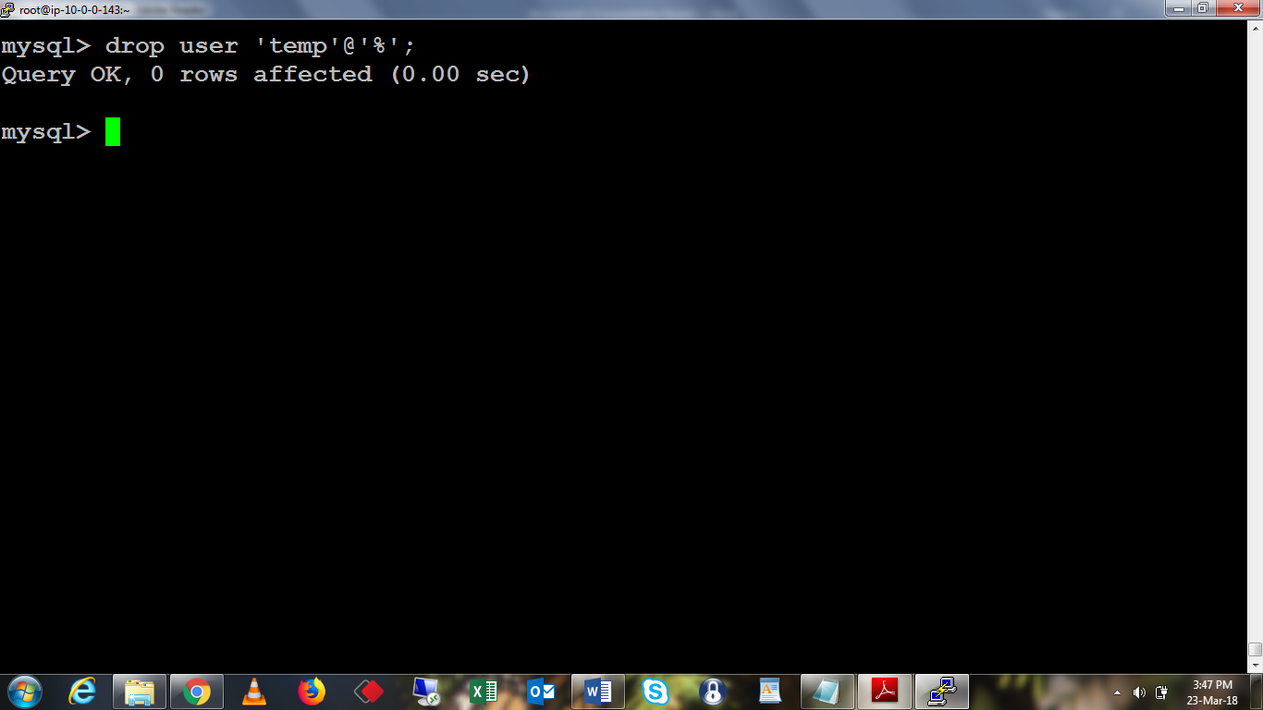

service cloudera-scm-server status

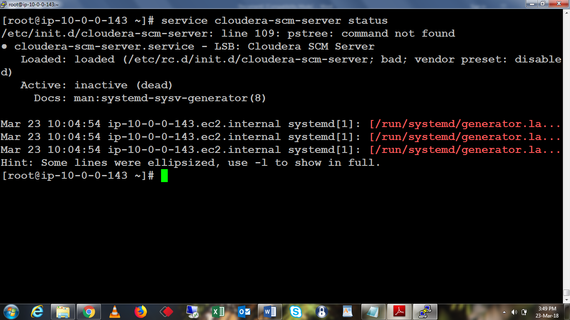

service cloudera-scm-server start

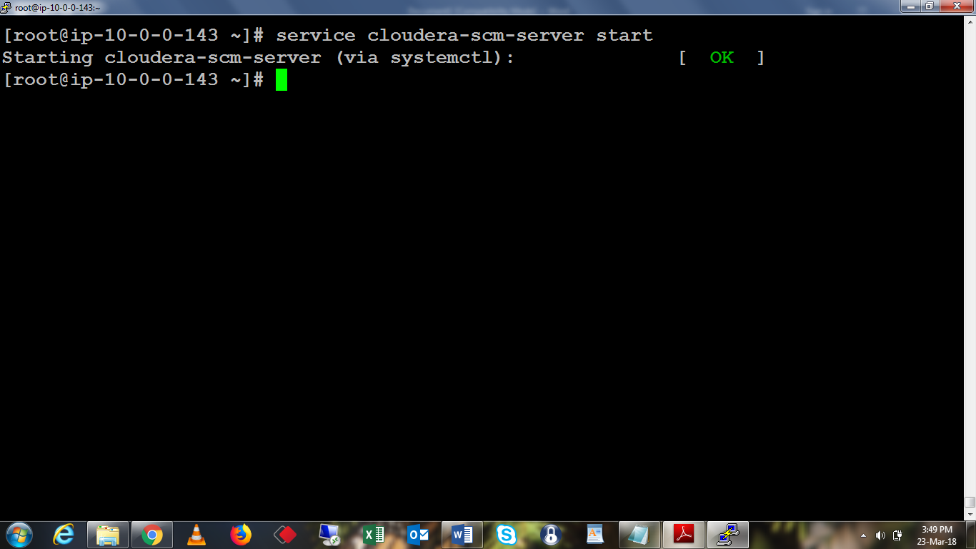

tail -f /var/log/cloudera-scm-server/cloudera-scm-server.log

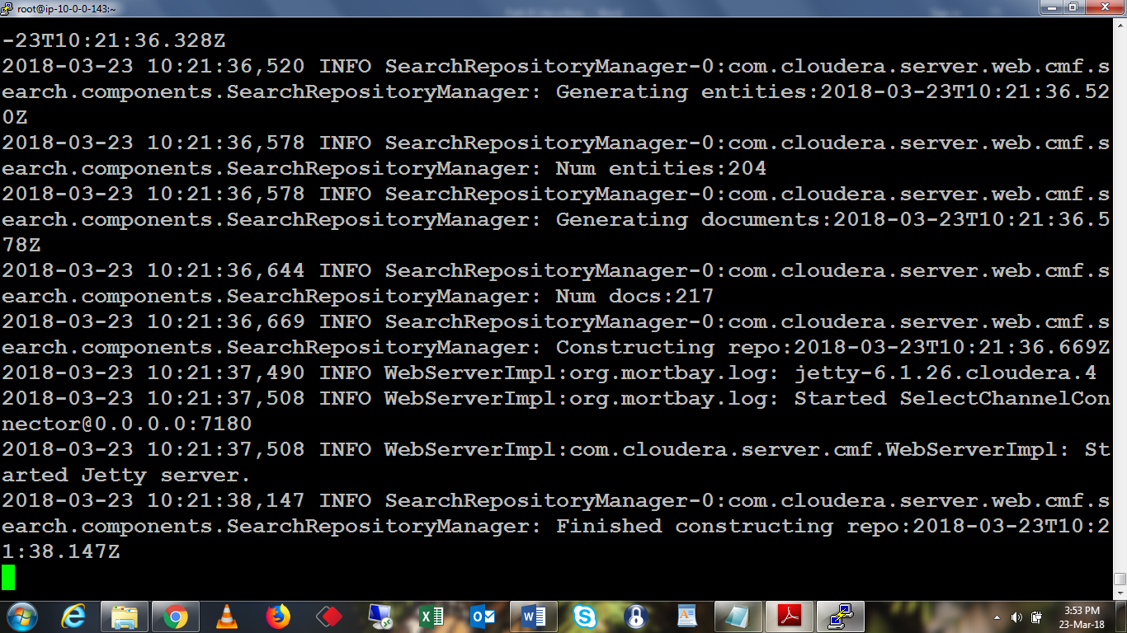

netstat -nap | grep 7180

